**ALIA WAQAS**

**221367**

**BSCS 5C**

**OPERATING SYSTEM**

**ASSIGNMENT NO 03**



**Comparative Analysis of Android and macOS Based on Operating System Concepts**

**1. Introduction**

Operating systems (OS) serve as the backbone of computing devices, managing hardware resources and providing services for application software. This report presents a comparative analysis of two operating systems: **Android** (a mobile OS) and **macOS** (a desktop OS). The comparison is based on critical OS concepts including **process management**, **memory management**, **file systems**, **security**, and **scheduling**.

**Research Papers**

* **Android:** "Comparative Analysis of Modern Operating Systems" (NIJOCET, 2022)​.
* **macOS:** "Comparative Study of Operating System Quality Attributes" (Odun-Ayo et al., 2021)​.

**2. Process Management**

**Android:**

* **Process Lifecycle:**
  + Android apps transition between states: running, paused, stopped, or killed. The **Activity Manager** manages the app lifecycle to optimize system resources.
  + Background processes are frequently terminated by the **Low Memory Killer (LMK)** to free up RAM.
* **Zygote Process:**
  + Android's **Zygote** is a daemon process responsible for initializing the Dalvik or ART runtime and creating new app processes by forking itself. This mechanism reduces app startup time significantly.
* **Multitasking:**
  + Android employs preemptive multitasking, where foreground apps are given priority over background apps.
* **Binder IPC:**
  + Android's **Binder IPC** framework ensures fast, secure communication between processes, particularly for app-to-system or app-to-app interactions.

**macOS:**

* **Task Management:**
  + macOS uses the **Mach kernel**, which provides advanced task management by assigning a unique **task port** to each process. Tasks are isolated and managed independently.
* **Threads and Multithreading:**
  + macOS supports **preemptive multithreading**, allowing efficient use of CPU resources. It also provides **Grand Central Dispatch (GCD)** to optimize thread management.
* **Inter-Process Communication (IPC):**
  + macOS leverages **Mach messaging**, enabling fast and secure communication between processes using ports.

**Additional Explanation:** The **Mach kernel** in macOS separates processes into tasks and threads, enabling granular resource allocation. Android’s **Zygote** and Binder IPC framework, on the other hand, are designed for resource-constrained environments, making them highly efficient for mobile devices.

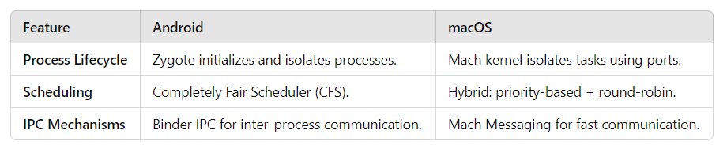

Android Lifecycle (App Processes): Init --> Zygote (Fork) --> App Process --> Pause/Stop/Kill

macOS Lifecycle (Tasks and Threads): Init --> Mach Task Port --> Threads --> Multi-Threading

**3. Memory Management**

**Android:**

* **Heap Management:**
  + Each app runs with a private heap, and memory allocation is managed by the Dalvik/ART runtime.
* **Garbage Collection:**
  + Automatic garbage collection ensures that unused objects are cleaned up without manual intervention. However, this can occasionally lead to "GC pauses," which affect app performance.
* **Low Memory Killer (LMK):**
  + LMK proactively terminates background apps to free up memory, ensuring smooth operation for active tasks.

**macOS:**

* **Virtual Memory:**
  + macOS uses a **virtual memory** system with demand paging. Physical memory (RAM) is supplemented by disk space to handle large workloads.
* **Memory Compression:**
  + When physical memory is exhausted, macOS compresses memory pages instead of writing them to disk, improving performance during high loads.
* **Protection:**
  + macOS ensures that each app operates in isolated memory spaces, preventing accidental overwrites or malicious access.

**Additional Explanation:** macOS's **memory compression** and virtual memory system ensure superior performance under high workloads. Android’s memory model, optimized for mobile devices, focuses on lightweight and dynamic allocation.

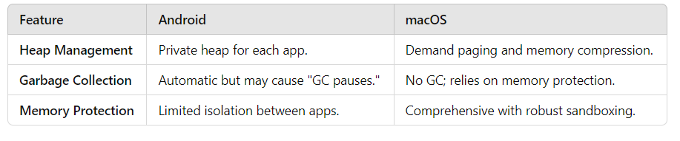

Android: [Heap Memory] --> [GC] --> [LMK]

macOS: [RAM] <--> [Compressed Pages] <--> [Virtual Memory]

**4. File System**

**Android:**

* **ext4 File System:**
  + The **ext4** file system supports journaling, ensuring data integrity in case of crashes. It is lightweight and efficient for mobile devices.
* **Scoped Storage:**
  + Introduced in Android 10, scoped storage restricts app access to only its files unless explicitly granted permissions, enhancing data security.

**macOS:**

* **Apple File System (APFS):**
  + APFS is designed for modern storage media like SSDs, providing faster read/write speeds, snapshots for backups, and full-disk encryption.
* **HFS+ (Legacy):**
  + Earlier macOS versions used **HFS+**, which lacked the advanced features of APFS.

**Additional Explanation:** APFS offers advanced features like **cloning** (creating copies of files without additional disk space) and real-time encryption. Android's **ext4** is simpler but optimized for performance on constrained storage devices.

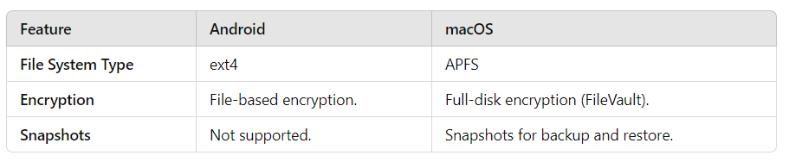

Android: [ext4 Journaling File System]

|-- Internal Storage

|-- External SD Card

macOS: [APFS Hierarchical Structure]

|-- Snapshots

|-- Encryption

**5. Security**

**Android:**

* **App Sandboxing:**
  + Apps run in isolated environments, reducing the risk of one app compromising another.
* **File-Based Encryption:**
  + Encrypts individual files instead of the entire disk, enabling quick decryption during app access.
* **Google Play Protect:**
  + Android scans apps for malware and provides frequent updates to address vulnerabilities.

**macOS:**

* **System Integrity Protection (SIP):**
  + SIP prevents unauthorized changes to critical system files.
* **Gatekeeper:**
  + Ensures that only trusted software from identified developers or the Mac App Store is installed.
* **FileVault:**
  + Full-disk encryption protects user data in case the device is lost or stolen.

**Additional Explanation:** macOS provides enterprise-grade security with **SIP** and **FileVault**, while Android’s **Google Play Protect** focuses on securing apps in a fragmented ecosystem.

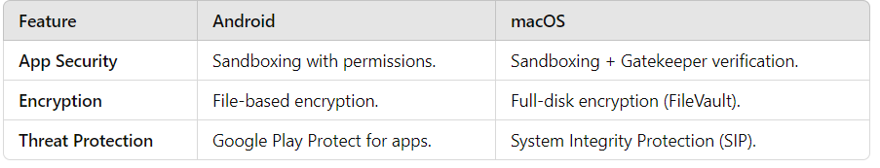

Android: [Permissions Model] --> [Google Play Protect] --> [File-Based Encryption] macOS: [Gatekeeper] --> [SIP] --> [FileVault Encryption]

**6. Scheduling**

**Android:**

* Android relies on the **Completely Fair Scheduler (CFS)** from the Linux kernel. It dynamically adjusts process priorities, ensuring fairness and responsiveness.

**macOS:**

* macOS uses **multi-queue scheduling**, combining features of priority-based and round-robin scheduling. It also incorporates **real-time scheduling** for latency-sensitive tasks like audio processing.

**Additional Explanation:** While both OSs excel at handling multiple processes efficiently, macOS's hybrid approach allows for finer control, especially in scenarios involving high-performance applications.

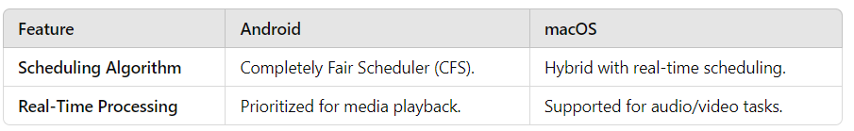

**7. Creative Analogy**

Imagine **Android** as a busy train station where trains (processes) are dispatched based on demand, with the station master (LMK) ensuring there’s enough room for incoming passengers. In contrast, **macOS** is like a high-security research lab with dedicated workspaces (memory isolation) and strict entry protocols (Gatekeeper).

**8. Insights and Observations**

1. **Strengths:**
   * Android’s flexibility and support for a wide range of devices make it highly adaptable.
   * macOS provides unmatched security and smooth integration with Apple’s ecosystem.
2. **Weaknesses:**
   * Android’s fragmentation (different OS versions across devices) impacts update consistency.
   * macOS’s closed ecosystem limits user customization and cross-platform compatibility.

**9.Conclusion**

Android and macOS represent two ends of the OS spectrum. Android excels in adaptability and affordability, while macOS is unparalleled in security and ecosystem integration. Understanding these differences highlights the importance of tailoring OS choice to user needs and device environments.